**Ideation Phase**

**Define the Problem Statements**

|  |  |
| --- | --- |
| Date | 27 June2025 |
| Team ID | LTVIP2025TMID34066 |
| Project Name | SmartSDLC – AI-Enhanced Software Development Lifecycle |
| Maximum Marks | 2 Marks |

**Customer Problem Statement:**

Software developers and project teams often face challenges in managing the software development lifecycle efficiently. Common issues include debugging complex code, generating accurate test cases, transforming requirements, and receiving timely support for development-related queries. Current tools are often disjointed, lack intelligent automation, and require switching between multiple platforms. There is a growing need for a unified, AI-powered assistant that can simplify SDLC processes, offer real-time support, and enhance productivity through contextual, personalized recommendations.

**Example:**

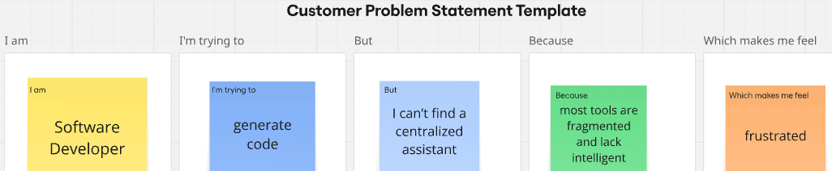

|  |  |  |  |  |  |
| --- | --- | --- | --- | --- | --- |
| **Problem Statement (PS)** | **I am (Customer)** | **I’m trying to** | **But** | **Because** | **Which makes me feel** |
| PS-1 | software developer | get help with debugging, generating code, and understanding requirements | I can’t find a centralized assistant that supports all phases of the SDLC. | most tools are fragmented and lack intelligent, contextual guidance | frustrated, blocked, and less productive. |
| PS-2 | project manager / team lead. | manage SDLC tasks, review test cases, and monitor progress efficiently | I lack a smart platform that streamlines development tasks and supports my team | current tools are not collaborative or AI-powered to assist with coding or documentation needs | overwhelmed and unable to maintain consistent development workflow |